Recent Modifications to the OSPA GoldSheet, February 2013

OSPA has made changes to the GoldSheet to facilitate the implementation of Kuali Coeus, to implement the new ISU F&A rates, and to update questions and fix typos.

The first change is to facilitate use of ISU’s new facilities and administrative (F&A) cost rates. The F&A section of the GoldSheet has been revised to provide a drop-down menu of the F&A rates authorized in the university’s F&A rate agreement.

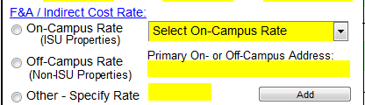

The second change is to use terminology consistent with Kuali Coeus and eData. As a result, the term “Admin DICE” has been changed to “Lead Unit DICE.” Additionally, all references to “Co-Principal Investigator” have been changed to “Co-Investigator” throughout the GoldSheet.

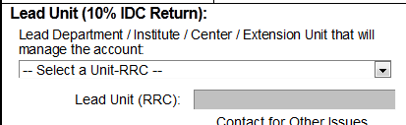

The third change to be implemented provides additional clarity to a few of the compliance questions on the GoldSheet. At the request of several ISU units, OSPA modified the GoldSheet space and utilities question to reference High Performance Computing (HPC). The question now reads as follows:
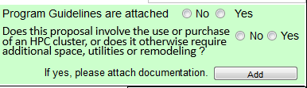
OSPA also slightly modified the intellectual property and export control related compliance questions.
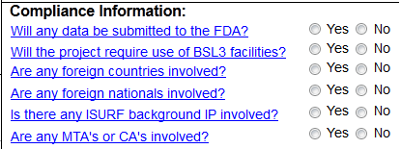
Please let us know if you have any questions about these modifications or if we can provide additional information about these changes. Thank you for your continuing support of OSPA!

